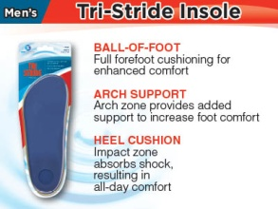

**ARCH SUPPORTS**

For flat feet, we recommend **Tri Stride Insoles**. These are supports that you put inside your shoe, to help support the arch of your foot. This picture shows the men’s support, but there are of course women’s sizes too

You wear them inside both of your shoes, even if only one foot is causing problems.

They are not expensive [$10 or less], and you don’t need a prescription for them. They can be found at any **Wal-Mart**, usually on the end of an aisle in the shoe section. If you don’t find them, show this to a Wal Mart employee and they can guide you to them.

They come in men’s and women’s sizes, but usually one size fits just about everyone. For the first few day that you wear them in your shoes, you feel like your feet are tilting outward.

Then, after a few days, the foot pain that you had will start to go away. You usually need these for life, but they last a long time, and are easy to move from shoe to shoe.

For the ladies : it is fine to wear stylish shoes to church or to social occasions, but for every day wear, you will probably want a soft soled shoe like a Nike or New Balance shoe, or Famolare or SAS shoes